WS 2025/26

Lab course: Human Robot Interaction

Task 5: Verbal interaction

Chair of Autonomous Systems and Mechatronics
Friedrich-Alexander-Universität Erlangen-Nürnberg

TEAM 1 :
Velayudhan Aravindakshan - ju08rufe
Akhilan David Karthikeyan - ug39owys
Wei Zhang - jo07wuwe

Exercise 1

We had referred the below mentioned html and youtube to have a basic understanding of the NAO robot and the interface used for the flashing of the NAO robot(softbank robotics choregraphe tool)
http://doc.aldebaran.com/2-8/getting_started/helloworld_choregraphe.html

https://youtube.com/playlist?list=PL7Sf9IQyLv99iM40aDDSSKR93kx8jQA7Y&si=ybCX4UniT2OiOUf8

Aldebaran NAO Tutorial Video 1 "Say"

Exercise 2

a.
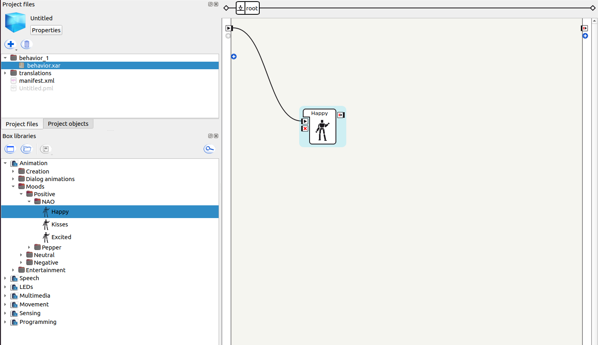

When executing the Animation->Moods->Positive->NAO->Happy with the NAO robot simulation result is the robot dancing for a few seconds with the use of its hands and legs and head.

b.
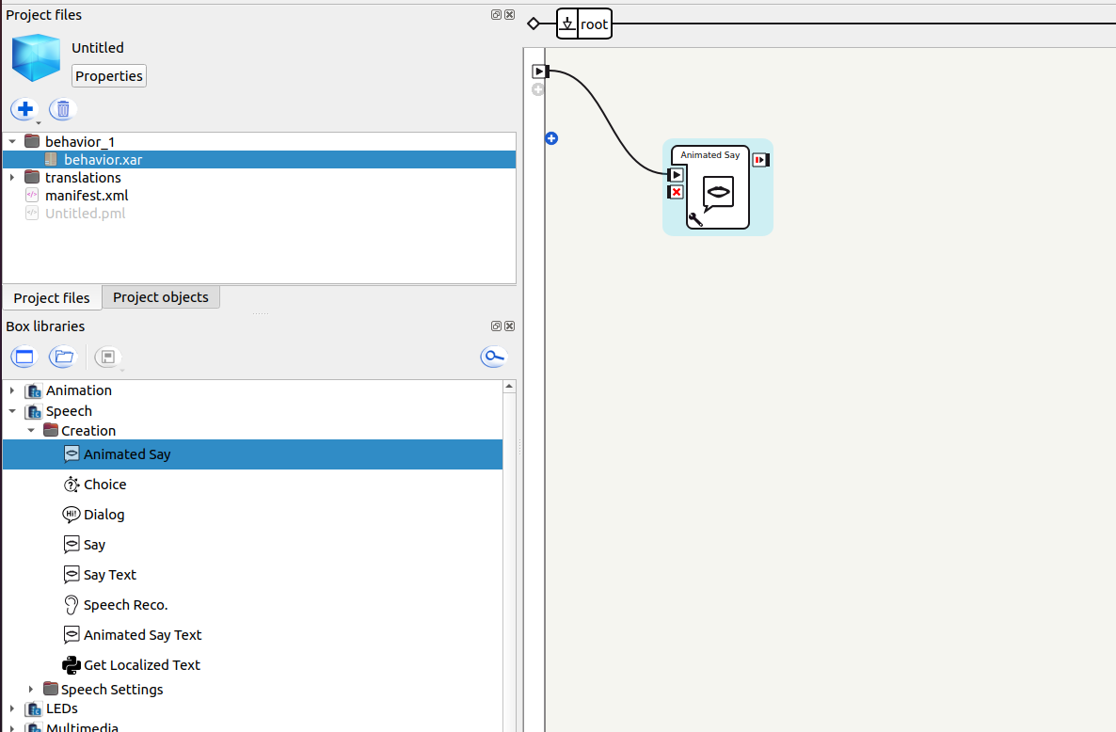
When executing the Speech->Creation->Animated Say with the NAO robot simulation result is the robot having a popup window with the text given in the box properties, with a slight movement in the head.

c.
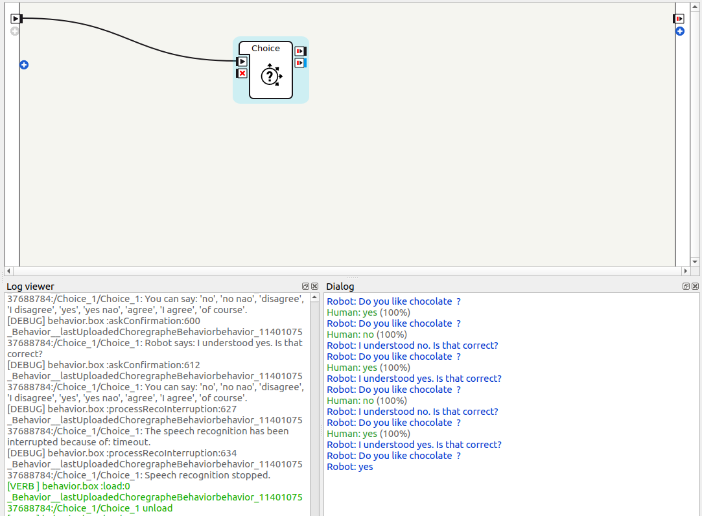
When executing the Speech->Creation->Choice with the NAO robot simulation the result is a question being projected in the dialog box and an input for the answer should be requested which would be compared with the list present in the array of answers within the choice block.
d. 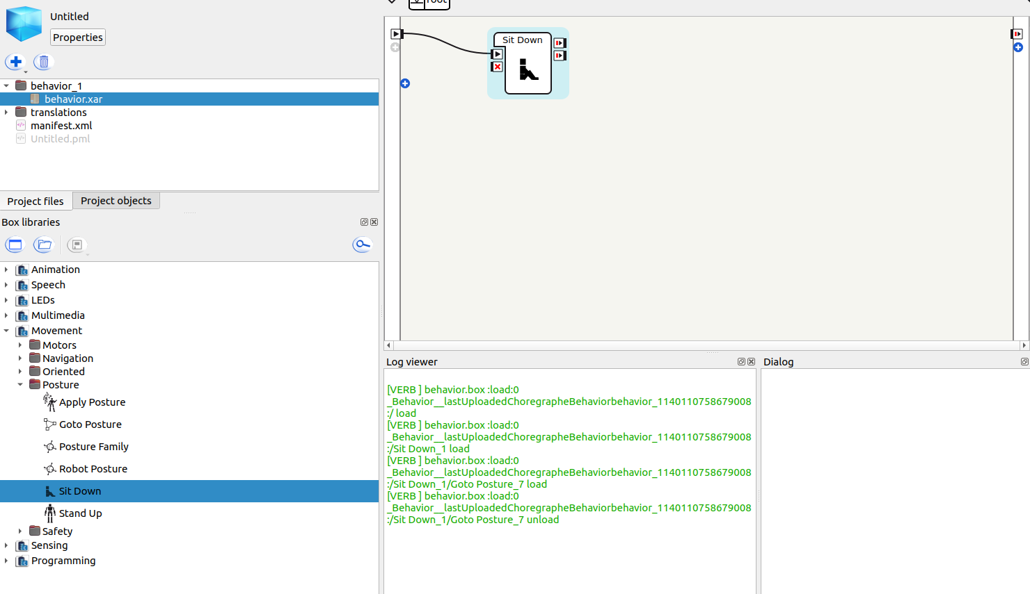

When executing the Movement->Posture->Sit Down with the NAO robot simulation, the result is the robot performs a series of movement to move from the standing position to sitting position.
e. 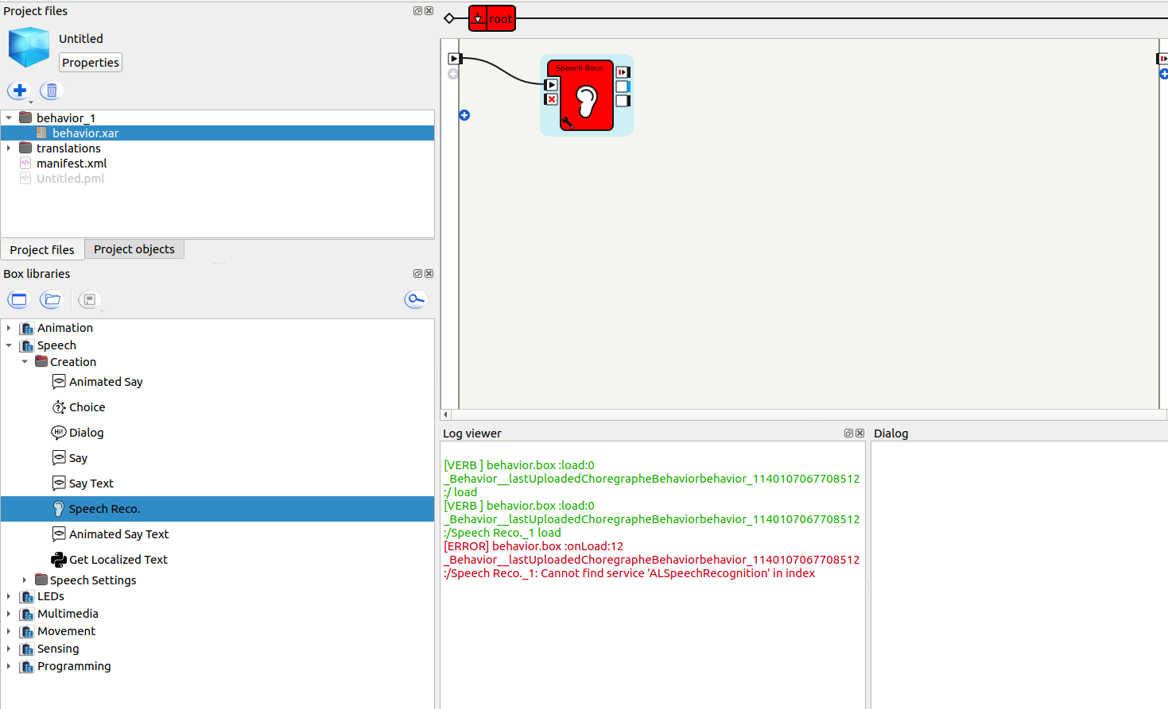

When executing the Speech->Creation->Speech recognition with the NAO robot simulation, it results in an error. Checking with the error log it is understood that the service ‘ALSpeechRecognition’ is missing. The most probable cause is absence of audio input processed by the robot’s hardware. The virtual simulation does not emulate the necessary microphone hardware or complex processing environment required for the speech recognition. So as a result in order to use the speech recognition box it is necessary to be connected to a physical NAO robot.

Exercise 3
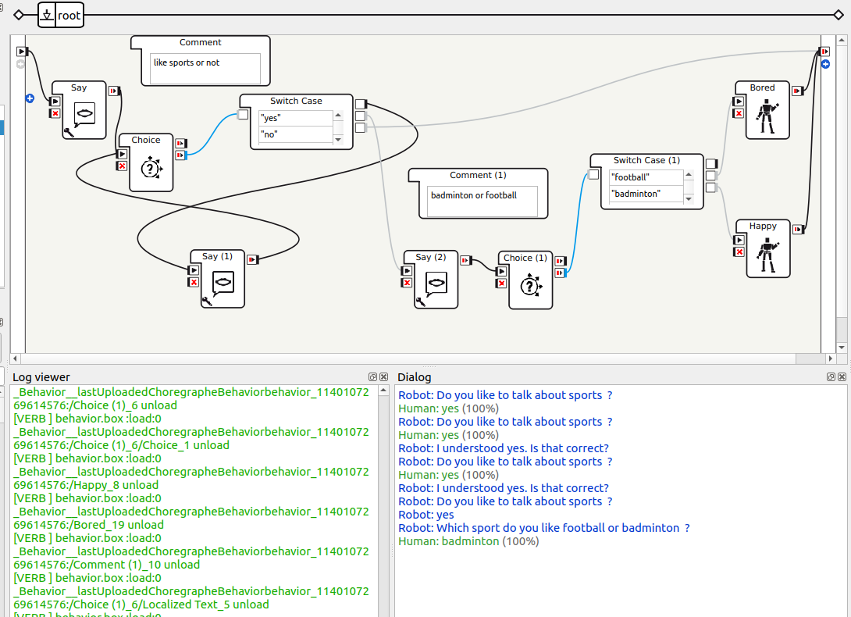

The flow chart was constructed and corresponding input were given for the program to work. However there was a significant delay for the response of the choice block to the switch block. The proceeding flow was sometimes manually triggered(example choice(1))

Exercise 4

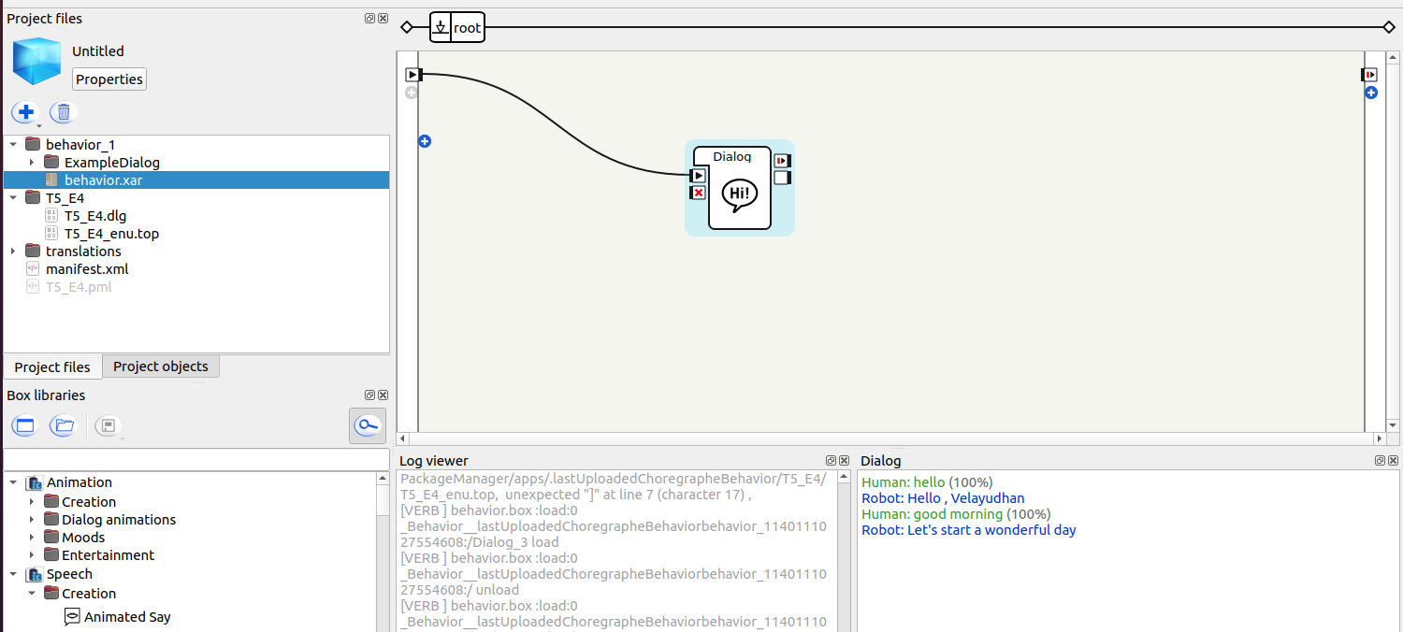
The steps from the tutorial were followed and successful conversion between the NAO robot was performed.

Exercise 5

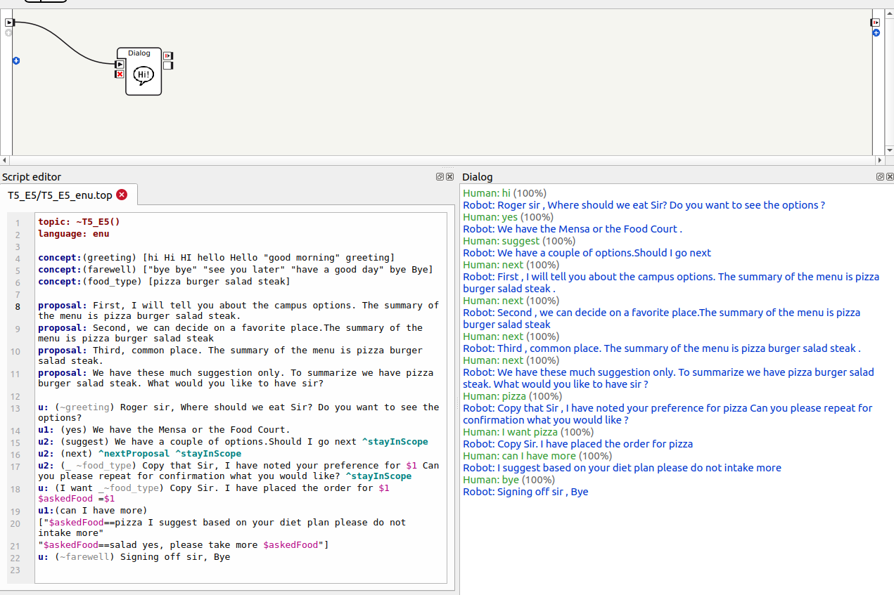

We included the concepts,proposals,logical comparisons and multilayer commands along with the stayInScope in order to complete a simple robot to human comparison which asked the human what he prefers to eat along with a simple scenario.The code is tested for all the functionality used within the code on the simulated NAO robot. The code used is attached below.
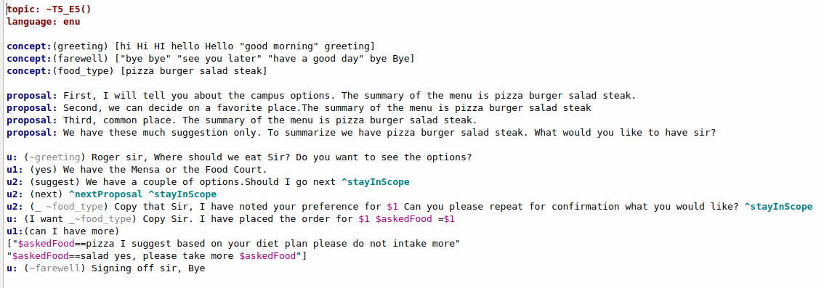
The dialog output is attached below
